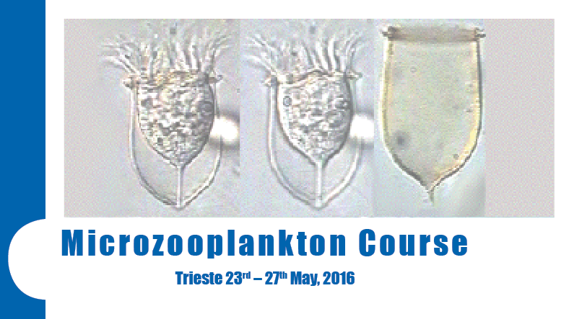

APPLICATION FORM

Please complete the form in BLOCK CAPITALS

- Surname or Family Name:

- First Name or Given Name(s):

- Address for correspondence:

- Telephone Number:

- Email:

- Date Of Birth:

- Highest educational level achieved:

- Present professional employment:

- Field of study/research:

- Why the Couse will help your scientific career?

Signature: Date:

When completed, this form should be returned to bcataletto@inogs.it

INCLUDE A CV TO YOUR APPLICATION FORM

APPLICATION WITHOUT THE CV WILL BE NOT ELIGIBLE

